A Comprehensive Introduction to Graph Neural Networks (GNNs)

Learn everything about Graph Neural Networks, including what GNNs are, the different types of graph neural networks, and what they're used for. Plus, learn how to build a Graph Neural Network with Pytorch.

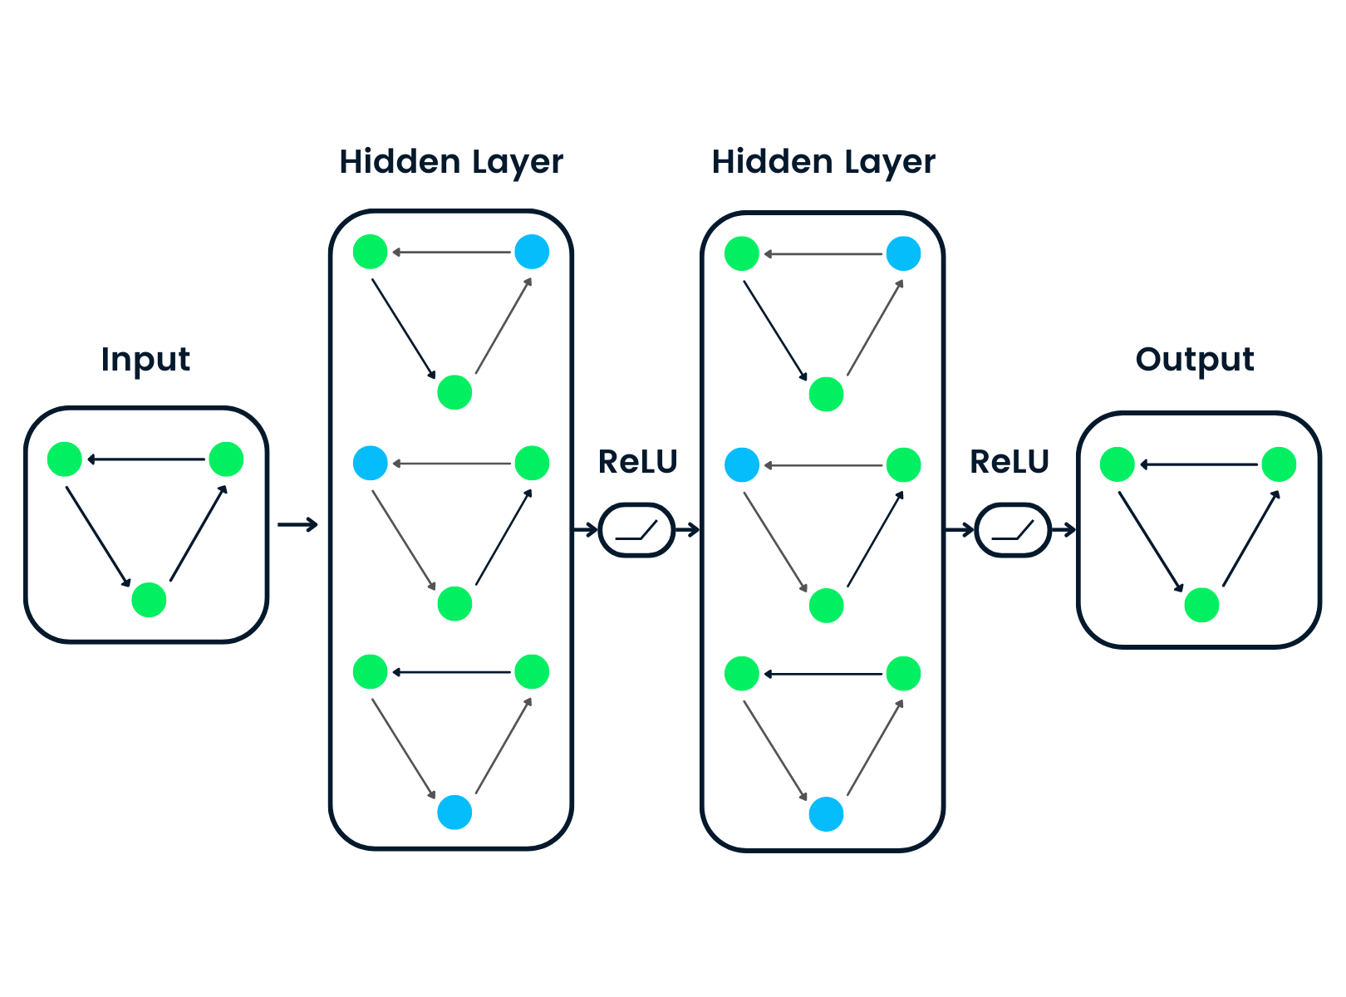

What is a Graph?

A Graph is the type of data structure that contains nodes and edges. A node can be a person, place, or thing, and the edges define the relationship between nodes. The edges can be directed and undirected based on directional dependencies.

In the example below, the blue circles are nodes, and the arrows are edges. The direction of edges defines dependencies between two nodes.

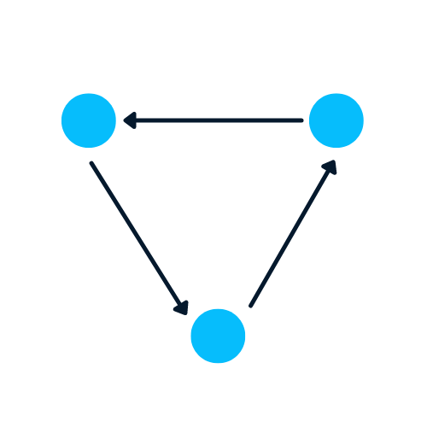

Let’s learn about the complex Graph da . It contains 198 nodes and 2742 edges. In the community graph plot below, different colors of nodes represent various communities of Jazz musicians and the edges connecting them. There is a web of collaboration where a single musician has relationships within and outside the community

Graphs are excellent in dealing with complex problems with relationships and interactions. They are used in pattern recognition, social networks analysis, recommendation systems, and semantic analysis. Creating graph-based solutions is a whole new field that offers rich insights into complex and interlinked datasets.

. 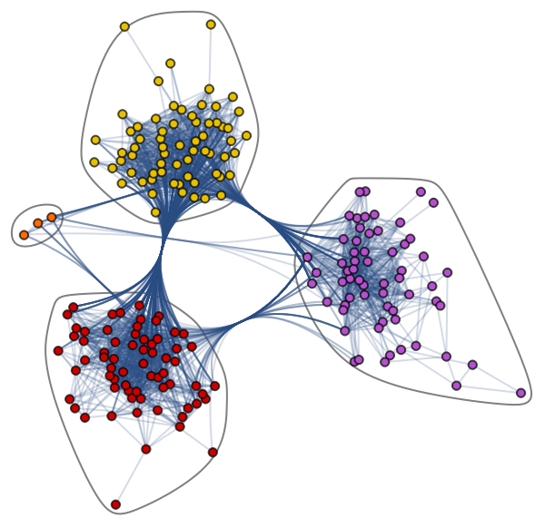

Nodes and Edges:

Nodes: In the context of this dataset, nodes likely represent individual jazz musicians. With 198 nodes, it suggests there are 198 musicians in the dataset.

Edges: Edges represent connections or collaborations between musicians. With 2742 edges, there are numerous instances of musicians collaborating with each other.

Community Detection:

Communities: In graph theory, communities are subsets of nodes that are more densely connected internally than with the rest of the network. In this case, different colors are used to represent various communities of jazz musicians. Musicians within the same community likely have more collaborations among themselves compared to musicians in different communities.

Web of Collaboration:

The term "web of collaboration" implies a complex network where each musician is connected to others, forming a intricate structure of collaborations. This could include musicians working within their own community and also reaching out to collaborate with musicians from other communities.

Visualization:

The community graph plot provides a visual representation of the network. The use of colors to differentiate communities makes it easier to identify clusters of musicians who collaborate more closely with each other.

Network Analysis:

Analyzing such a graph can reveal interesting patterns, such as central musicians who collaborate with many others, the overall connectivity of the network, and the strength of connections within and between communities.

Potential Insights:

This dataset could offer insights into the dynamics of jazz collaborations. It might help identify influential musicians, popular communities, or trends in cross-community collaborations.

Further Exploration:

To gain more insights, you could explore metrics like centrality (to identify important nodes), clustering coefficients (to understand the density of connections), and possibly perform additional analyses or visualizations.

Graphs with NetworkX

In this section, we will learn to create a graph using NetworkX. The code below is influenced by

Daniel Holmberg's blog on Graph Neural Networks in Python.

Create networkx’s DiGraph object “H” Add nodes that contain different labels, colors, and size Add edges to create a relationship between two nodes.

For example, “(0,1)” means that 0 has a directional dependency on 1

We will create bidirectional relationships by adding “(1,0)”

Extract colors and sizes in the form of lists Plot the graph using networkx’s draw function

import networkx as nx

H = nx.DiGraph()

#adding nodes

H.add_nodes_from([

(0, {"color": "blue", "size": 250}),

(1, {"color": "yellow", "size": 400}),

(2, {"color": "orange", "size": 150}),

(3, {"color": "red", "size": 600})

])

#adding edges

H.add_edges_from([

(0, 1),

(1, 2),

(1, 0),

(1, 3),

(2, 3),

(3,0)

])

node_colors = nx.get_node_attributes(H, "color").values()

colors = list(node_colors)

node_sizes = nx.get_node_attributes(H, "size").values()

sizes = list(node_sizes)

#Plotting Graph

nx.draw(H, with_labels=True, node_color=colors, node_size=sizes)

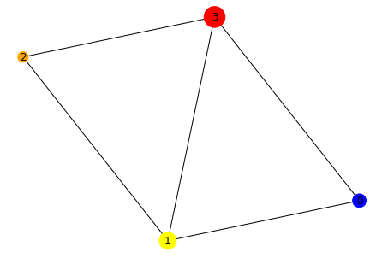

This code uses the NetworkX library to create a directed graph (DiGraph) and add nodes and edges to it. • First, the code imports the NetworkX library as nx and creates an empty directed graph H using the DiGraph() function. • Next, the code adds nodes to the graph using the add_nodes_from() function. • Each node is represented by a tuple with two elements: the first element is the node ID (an integer), and the second element is a dictionary of node attributes (in this case, "color" and "size"). • The add_nodes_from() function takes a list of these tuples as an argument. • After adding the nodes, the code adds edges to the graph using the add_edges_from() function. • Each edge is represented by a tuple of two node IDs. • The add_edges_from() function takes a list of these tuples as an argument. • The code then uses the get_node_attributes() function to get the "color" and "size" attributes of each node, and converts them to lists using the values() method. • These lists are then used to set the node_color and node_size parameters of the draw() function, which plots the graph using the draw() function from NetworkX. • Overall, this code creates a directed graph with four nodes and six edges, and plots it with node colors and sizes based on their attributes.

import networkx as nx

import matplotlib.pyplot as plt

# Create a directed graph object

H = nx.DiGraph()

# Add nodes with labels, colors, and sizes

nodes_data = {

0: {'label': 'Node 0', 'color': 'red', 'size': 100},

1: {'label': 'Node 1', 'color': 'blue', 'size': 150},

2: {'label': 'Node 2', 'color': 'green', 'size': 120},

# Add more nodes as needed

}

H.add_nodes_from(nodes_data)

# Add directed edges

edges = [(0, 1), (1, 0), (1, 2), (2, 0)]

H.add_edges_from(edges)

# Extract colors and sizes

node_colors = [data['color'] for _, data in H.nodes(data=True)]

node_sizes = [data['size'] for _, data in H.nodes(data=True)]

# Plot the graph

pos = nx.spring_layout(H) # You can use other layout algorithms

nx.draw(H, pos, with_labels=True, node_color=node_colors, node_size=node_sizes, font_size=10, font_color='white', font_weight='bold', edge_color='gray', arrowsize=20)

# Display the plot

plt.show()

Explanation:

We create a directed graph object H using nx.DiGraph().

Nodes are added with labels, colors, and sizes using the add_nodes_from method.

Directed edges are added using the add_edges_from method.

Colors and sizes are extracted from node attributes.

The graph is plotted using nx.draw with specified node colors, sizes, and other visual properties.

This example uses a small graph with three nodes, and you can extend it by adding more nodes and edges based on your specific requirements. Feel free to modify the code according to your needs!

#converting to undirected graph

G = H.to_undirected()

nx.draw(G, with_labels=True, node_color=colors, node_size=sizes)

This code converts a directed graph H to an undirected graph G using the to_undirected() method from the NetworkX library in Python. • Then, it uses the draw() function from the same library to visualize the graph G with labeled nodes, node colors specified by the colors variable, and node sizes specified by the sizes variable.

Why is it Hard to Analyze a Graph?

Graph-based data structures have drawbacks, and data scientists must understand them before developing graph-based solutions.

A graph exists in non-euclidean space. It does not exist in 2D or 3D space, which makes it harder to interpret the data. To visualize the structure in 2D space, you must use various dimensionality reduction tools.

Graphs are dynamic; they do not have a fixed form. There can be two visually different graphs, but they might have similar adjacency matrix representations. It makes it difficult for us to analyze data using traditional statistical tools.

Large size and dimensionality will increase the graph's complexity for human interpretations. The dense structure with multiple nodes and thousands of edges is harder to understand and extract insights.

What is a Graph Neural Network (GNN)?

Graph Neural Networks are special types of neural networks capable of working with a graph data structure. They are highly influenced by Convolutional Neural Networks (CNNs) and graph embedding. GNNs are used in predicting nodes, edges, and graph-based tasks.

**CNNs** are used for image classification. Similarly, GNNs are applied to graph structure (grid of pixels) to predict a class.

**Recurrence Neural Networks** are used in text classification. Similarly, GNNs are applied to graph structures where every word is a node in a sentence.

GNNs were introduced when Convolutional Neural Networks failed to achieve optimal results due to the arbitrary size of the graph and complex structure.

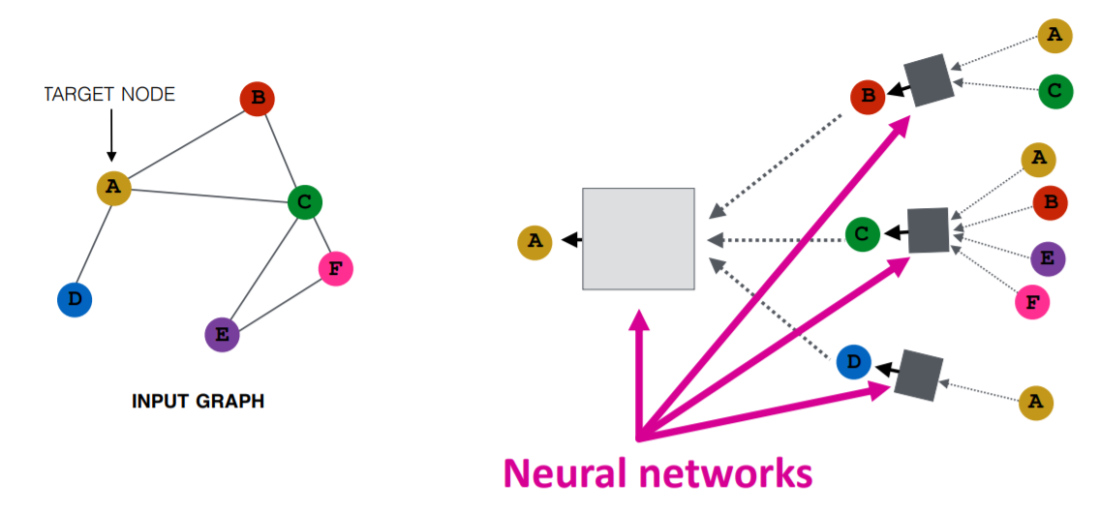

The input graph is passed through a series of neural networks. The input graph structure is converted into graph embedding, allowing us to maintain information on nodes, edges, and global context.

Then the feature vector of nodes **A** and **C** is passed through the neural network layer. It aggregates these features and passes them to the next layer

Types of Graph Neural Networks

There are several types of neural networks, and most of them have some variation of Convolutional Neural Networks. In this section, we will be learning about the most popular GNNs.

G**raph Convolutional Networks (GCNs)**are similar to traditional CNNs. It learns features by inspecting neighboring nodes. GNNs aggregate node vectors, pass the result to the dense layer, and apply non-linearity using the activation function. In short, it consists of Graph convolution, linear layer, and non-learner activation function. There are two major types of GCNs: Spatial Convolutional Networks and Spectral Convolutional Networks.

**Graph Auto-Encoder Networks** learn graph representation using an encoder and attempt to reconstruct input graphs using a decoder. The encoder and decoders are joined by a bottleneck layer. They are commonly used in link prediction as Auto-Encoders are good at dealing with class balance.

**Recurrent Graph Neural Networks(RGNNs)** learn the best diffusion pattern, and they can handle multi-relational graphs where a single node has multiple relations. This type of graph neural network uses regularizers to boost smoothness and eliminate over-parameterization. RGNNs use less computation power to produce better results. They are used in generating text, machine translation, speech recognition, generating image descriptions, video tagging, and text summarization.

**Gated Graph Neural Networks (GGNNs)** are better than the RGNNs in performing tasks with long-term dependencies. Gated Graph Neural Networks improve Recurrent Graph Neural Networks by adding a node, edge, and time gates on long-term dependencies. Similar to Gated Recurrent Units (GRUs), the gates are used to remember and forget information in different states.

.

Types of Graph Neural Networks Tasks

Below, we’ve outlined some of the types of GNN tasks with examples:

**Graph Classification**: we use this to classify graphs into various categories. Its applications are social network analysis and text classification.

Node Classification: this task uses neighboring node labels to predict missing node labels in a graph.

**Link Prediction**: predicts the link between a pair of nodes in a graph with an incomplete adjacency matrix. It is commonly used for social networks.

**Community Detection**: divides nodes into various clusters based on edge structure. It learns from edge weights, and distance and graph objects similarly.

**Graph Embedding**: maps graphs into vectors, preserving the relevant information on nodes, edges, and structure.

**Graph Generation**: learns from sample graph distribution to generate a new but similar graph structure.

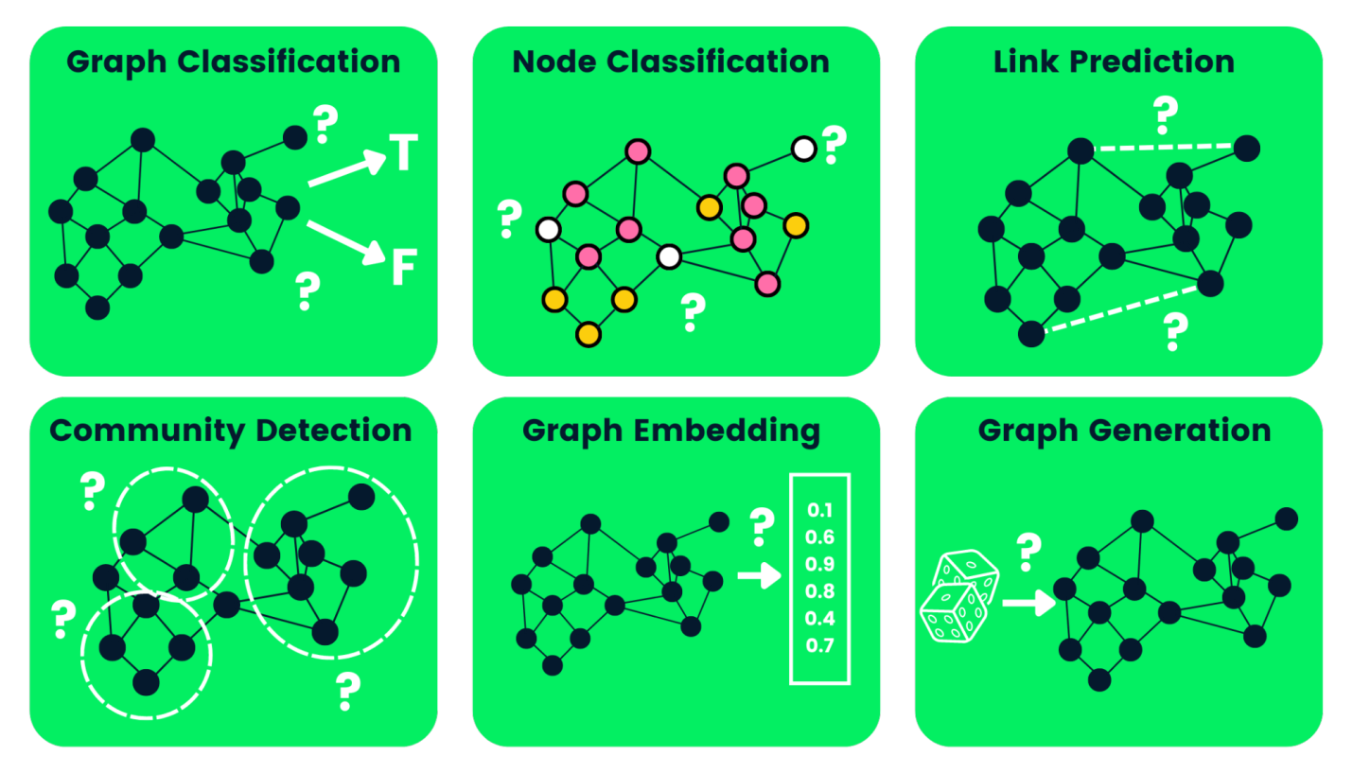

Disadvantages of Graph Neural Networks

There are a few drawbacks to using GNNs. Understanding them will help us determine when to use GNNa and how to optimize the performance of our machine learning models.

Most neural networks can go deep to obtain better performance, whereas **GNNs are shallow networks** mostly with three layers. It limits us from achieving state-of-the-art performance on large datasets.

The **graph structures are constantly changing**, making it harder to train a model on it.

Deploying the model to production faces **scalability issues** as these networks are computationally expensive. If you have a large and complex graph structure, it will be hard for you to scale the GNNs in production.

What is a Graph Convolutional Network (GCN)?

The majority of GNNs are Graph Convolutional Networks, and it is important to learn about them before jumping into a node classification tutorial.

The **convolution** in GCN is the same as a convolution in convolutional neural networks. It multiplies neurons with weights (filters) to learn from data features.

It acts as sliding windows on whole images to learn features from neighboring cells. The filter uses weight sharing to learn various facial features in image recognition systems 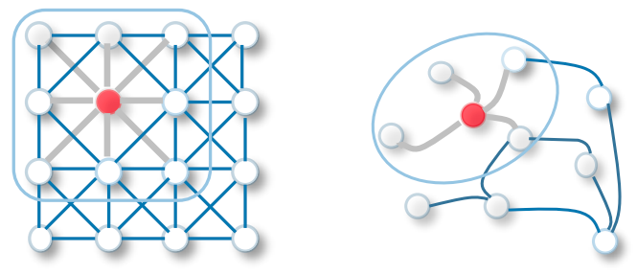

CNN vs GCN

Now transfer the same functionality to Graph Convolutional networks where a model learns the features from neighboring nodes. The major difference between GCN and CNN is that it is developed to work on non-euclidean data structures where the order of nodes and edges can vary.

There are two types of GCNs:

Spatial Graph Convolutional Networks use spatial features to learn from graphs that are located in spatial space.

Spectral Graph Convolutional Networks use Eigen-decomposition of graph Laplacian matrix for information propagation along nodes. These networks were inspired by wave propagation in signals and systems.

How do GNNs Work? Building a Graph Neural Network with Pytorch

We will build and train Spectral Graph Convolution for a node classification model. The code source is available on  workspace for you to experience and run your first graph-based machine learning model.

The coding examples are influenced by pytorch geometric   documentation.

Getting Started

We will install the  pytorch  package as**pytorch_geometric** is built upon it.

!pip install -q torch

Then we will use the torch version to install torch-scatter and torch-sparse. After that, we will install pytorch geometric latest release from GitHub.

%%capture

import os

import torch

os.environ['TORCH'] = torch.__version__

os.environ['PYTHONWARNINGS'] = "ignore"

!pip install torch-scatter -f https://data.pyg.org/whl/torch-${TORCH}.html

!pip install torch-sparse -f https://data.pyg.org/whl/torch-${TORCH}.html

!pip install git+https://github.com/pyg-team/pytorch_geometric.git

Planetoid Cora Dataset

Planetoid  is a citation network dataset from Cora, CiteSeer, and PubMed. The **nodes** are documents with 1433-dimensional bag-of-words feature vectors, and the **edges** are citation links between research papers. There are 7 classes, and we will train the model to predict missing labels.

We will ingest the Planetoid Cora dataset, and **row normalize** the bag of words input features. After that, we will analyze the dataset and the first graph object.

rom torch_geometric.datasets import Planetoid

from torch_geometric.transforms import NormalizeFeatures

dataset = Planetoid(root='data/Planetoid', name='Cora', transform=NormalizeFeatures())

print(f'Dataset: {dataset}:')

print('======================')

print(f'Number of graphs: {len(dataset)}')

print(f'Number of features: {dataset.num_features}')

print(f'Number of classes: {dataset.num_classes}')

data = dataset[0] # Get the first graph object.

print(data)

The Cora dataset has 2708 **nodes**, 10,556 edges, 1433 **features**, and **7** classes. The first object has 2708 train, validation, and test masks. We will use these masks to train and evaluate the model.

Dataset: Cora():

======================

Number of graphs: 1

Number of features: 1433

Number of classes: 7

Data(x=[2708, 1433], edge_index=[2, 10556], y=[2708], train_mask=[2708], val_mask=[2708], test_mask=[2708])

Node Classification with GNN

We will create a GCN model structure that contains two GCNConv layers **relu** activation and a **dropout** rate of 0.5. The model consists of 16 hidden channels

.  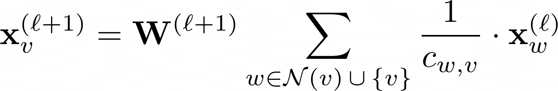

**GCN layer:**

The W(ℓ+1) is a tranable weight matrix in above equation and Cw,v donestes to a fixed normalization coefficient for each edge.

from torch_geometric.nn import GCNConv

import torch.nn.functional as F

class GCN(torch.nn.Module):

def __init__(self, hidden_channels):

super().__init__()

torch.manual_seed(1234567)

self.conv1 = GCNConv(dataset.num_features, hidden_channels)

self.conv2 = GCNConv(hidden_channels, dataset.num_classes)

def forward(self, x, edge_index):

x = self.conv1(x, edge_index)

x = x.relu()

x = F.dropout(x, p=0.5, training=self.training)

x = self.conv2(x, edge_index)

return x

model = GCN(hidden_channels=16)

print(model)

>>> GCN(

(conv1): GCNConv(1433, 16)

(conv2): GCNConv(16, 7)

)

Visualizing Untrained GCN network

Let’s visualize node embeddings of untrained GCN networks using sklearn.manifold.TSNE  and matplotlib.pyplot. It will plot a 7 dimension node embedding a 2D scatter plot.

%matplotlib inline

import matplotlib.pyplot as plt

from sklearn.manifold import TSNE

def visualize(h, color):

z = TSNE(n_components=2).fit_transform(h.detach().cpu().numpy())

plt.figure(figsize=(10,10))

plt.xticks([])

plt.yticks([])

plt.scatter(z[:, 0], z[:, 1], s=70, c=color, cmap="Set2")

plt.show()

We will evaluate the model then add training data to the untrained model to visualize various nodes and categories.

model.eval()

out = model(data.x, data.edge_index)

visualize(out, color=data.y)

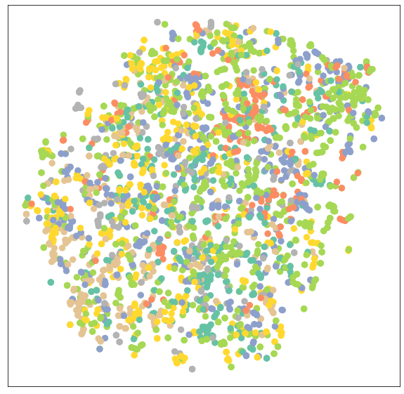

Training GNN

We will train our model on 100 Epochs using **Adam** optimization and the **Cross-Entropy Loss** function.

**In the train function, we have:**

Clear the gradient

Performed a single forward pass

Compute loss using training nodes

Calculate gradient, and update the parameters

**In the test function, we have:**

Predicted node class

Extracted class label with the highest probability

Checked how many values have been predicted correctly

Creating accuracy ratio using a sum of correct predictions divided by a total number of nodes.

model = GCN(hidden_channels=16)

optimizer = torch.optim.Adam(model.parameters(), lr=0.01, weight_decay=5e-4)

criterion = torch.nn.CrossEntropyLoss()

def train():

model.train()

optimizer.zero_grad()

out = model(data.x, data.edge_index)

loss = criterion(out[data.train_mask], data.y[data.train_mask])

loss.backward()

optimizer.step()

return loss

def test():

model.eval()

out = model(data.x, data.edge_index)

pred = out.argmax(dim=1)

test_correct = pred[data.test_mask] == data.y[data.test_mask]

test_acc = int(test_correct.sum()) / int(data.test_mask.sum())

return test_acc

for epoch in range(1, 101):

loss = train()

print(f'Epoch: {epoch:03d}, Loss: {loss:.4f}')

GAT(

(conv1): GATConv(1433, 8, heads=8)

(conv2): GATConv(64, 7, heads=8)

)

.. .. .. ..

.. .. .. ..

Epoch: 098, Loss: 0.5989

Epoch: 099, Loss: 0.6021

Epoch: 100, Loss: 0.5799

Model Evaluation

We will now evaluate the model on an unseen dataset using the **test** function, and as you can see, we got pretty good results on **81.5%** accuracy.

test_acc = test()

print(f'Test Accuracy: {test_acc:.4f}')

>>> Test Accuracy: 0.8150

We will now visualize the output embedding of a trained model to verify the results.

model.eval()

out = model(data.x, data.edge_index)

visualize(out, color=data.y)

As we can see, the trained model has produced better clustering of nodes for the same category.

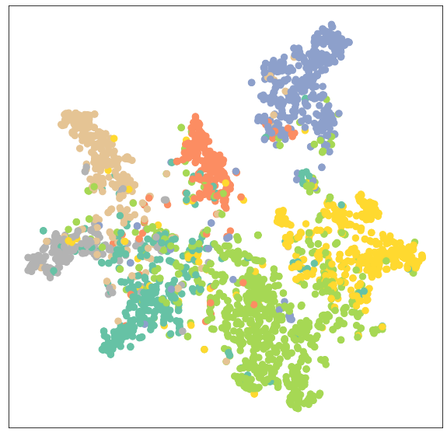

Training GATConv Model

In the second, we will replace GCNConv with GATConv  layers. The Graph Attention network  uses masked self-attentional layers to address the drawbacks of **GCNConv** and achieve state-of-the-art results.

You can also try other GNN layers and play around with optimizations, dropouts, and a number of hidden channels to achieve better performance.

In the code below, we have just replaced **GCNConv** with **GATConv** with **8 attention heads** in the first layer and 1 in the second layer.

**We will also set:**

dropout rate to 0.6

hidden channels to 8

learning rate 0.005

We have modified the **test** function to find the accuracy of a specific mask (valid, test). It will help us print out validation and test scores during model training. We are also storing validation and test results to a plot line chart later.

from torch_geometric.nn import GATConv

class GAT(torch.nn.Module):

def __init__(self, hidden_channels, heads):

super().__init__()

torch.manual_seed(1234567)

self.conv1 = GATConv(dataset.num_features, hidden_channels,heads)

self.conv2 = GATConv(heads*hidden_channels, dataset.num_classes,heads)

def forward(self, x, edge_index):

x = F.dropout(x, p=0.6, training=self.training)

x = self.conv1(x, edge_index)

x = F.elu(x)

x = F.dropout(x, p=0.6, training=self.training)

x = self.conv2(x, edge_index)

return x

model = GAT(hidden_channels=8, heads=8)

print(model)

optimizer = torch.optim.Adam(model.parameters(), lr=0.005, weight_decay=5e-4)

criterion = torch.nn.CrossEntropyLoss()

def train():

model.train()

optimizer.zero_grad()

out = model(data.x, data.edge_index)

loss = criterion(out[data.train_mask], data.y[data.train_mask])

loss.backward()

optimizer.step()

return loss

def test(mask):

model.eval()

out = model(data.x, data.edge_index)

pred = out.argmax(dim=1)

correct = pred[mask] == data.y[mask]

acc = int(correct.sum()) / int(mask.sum())

return acc

val_acc_all = []

test_acc_all = []

for epoch in range(1, 101):

loss = train()

val_acc = test(data.val_mask)

test_acc = test(data.test_mask)

val_acc_all.append(val_acc)

test_acc_all.append(test_acc)

print(f'Epoch: {epoch:03d}, Loss: {loss:.4f}, Val: {val_acc:.4f}, Test: {test_acc:.4f}')

.. .. .. ..

.. .. .. ..

Epoch: 098, Loss: 1.1283, Val: 0.7960, Test: 0.8030

Epoch: 099, Loss: 1.1352, Val: 0.7940, Test: 0.8050

Epoch: 100, Loss: 1.1053, Val: 0.7960, Test: 0.8040

As we can observe, our model didn’t perform better than **GCNConv**. It requires hyperparameter optimization or more Epochs to achieve state-of-the-art results.

Model Evaluation

In the evaluation part, we visualize validation and testing scores using **matplotlib.pyplot’s**line plot.

import numpy as np

plt.figure(figsize=(12,8))

plt.plot(np.arange(1, len(val_acc_all) + 1), val_acc_all, label='Validation accuracy', c='blue')

plt.plot(np.arange(1, len(test_acc_all) + 1), test_acc_all, label='Testing accuracy', c='red')

plt.xlabel('Epochs')

plt.ylabel('Accurarcy')

plt.title('GATConv')

plt.legend(loc='lower right', fontsize='x-large')

plt.savefig('gat_loss.png')

plt.show()

Ater 60 Epochs, the validation, and testing accuracy has achieved a stable value of **0.8**+/-0.02.

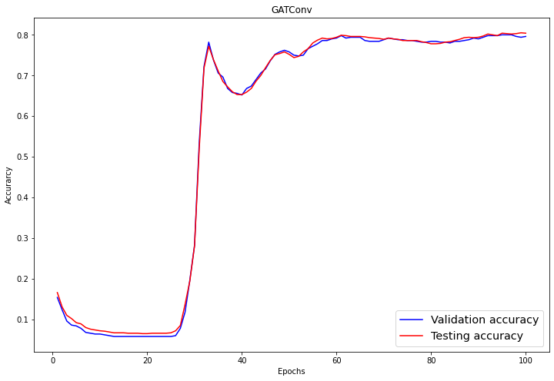

Again, let’s visualize the node clustering of the **GATConv** model.

model.eval()

out = model(data.x, data.edge_index)

visualize(out, color=data.y)

As we can see, the **GATConv** layer has produced the same results in clustering on the same category of nodes.

We can reduce overfitting by adding a second validation dataset and improve model performance by experimenting with various GCN layers from pytorch_geometric

The source code of the tutorial is available on DATACAMP WORKSPACE. You just need to click on the **Copy & Edit** button and run the Jupyter Notebook.

What are Graph Neural Networks used for?

Graph Neural Networks are directly applied to graph datasets and you can train them to predict nodes, edges, and graphs-related tasks. It is used for graph and node classification, link predictions, Graph clustering and generating, and image and text classification.

What is a Graph in a Graph Neural Network?

How powerful are Graph Neural Networks?

Do Neural Networks use Graph theory?

What are Graph Convolutional Networks?

What is a Graph in Deep Learning?